**Day 3 Lab Assignments**

**Do the following CSS style for the given HTML page** (run the page and see the result after each point)**:**

1. Make External CSS file for that:
   1. Make the font type "Lucida Calligraphy" for any p or div or span tag (use one CSS rule).
   2. <h1> tag which is child from div tag to be in the center of the page.
2. Make inline style for the div with "header" id, that make its width=100%, and its background color red.
3. Make inline style for the span which its id is "linksbar" , that make its width=25%, its background color gray, and make it starts from the left of the page (float property).
4. Make inline style for the span which its id is "content", that make its width=75%, its back color pink, and make it comes to the left side after the previous span (float property).
5. Make internal style that:
   1. Make a class name "none-bullet-list" that can be applied on <ul> tags, and makes list style type of the <ul> without bullets (none), and apply this class on the <ul> tag that contains the links (apply it to the <ul> tag in html directly, the selector will be class name only).
   2. Make color red, and background color pink for the links that're direct child for <li> tag, which inside span with id= "linksbar", and make it appear without underline (text-decoration property).
   3. Make color pink, and background color red for the links that're direct child for <li> tag, which ( inside span with id= "linksbar", when mouse is over it.
   4. Make the font weight bold, and font size 12px, for the paragraph that comes directly after (sibling) <h2> tag which is direct child for <span> with id="content".
   5. Make a dashed border, with size 2, and color rgb(20,70,60), for the div with id " loginform".
   6. Make style that makes the background color yellow of the any <input> of type "text", and another style that makes its background color white when it's focused.
   7. Make a class named "tabled-bordered" that can be applied on any tag, and make it displayed as table cells (use display property), its padding 5, and make a border for it. Apply the class to the 3 <p> tags that are in the "titles" div (apply them on the p tags that are in "titles" div in html file, the selector will be class name only).
      1. Try to change the <p> tags inside the div with id "titles" to spans, is there any difference?
   8. Use ::after pseudo element, to add this text “Read this” with color yellow” after the paragraph that is nested from span.
6. Make 2 internal styles as the following (With the same order):
   1. Color yellow for the <p> with id "aboutus" that's direct child from span with id "content".
   2. Color red for the <p> with id "aboutus".

**Which style will be applied to the paragraph? And why?**

1. Use !important with the second style of the previous 2 styles. What's the change that happened and why?

The page should be like that after you apply the previous styles:

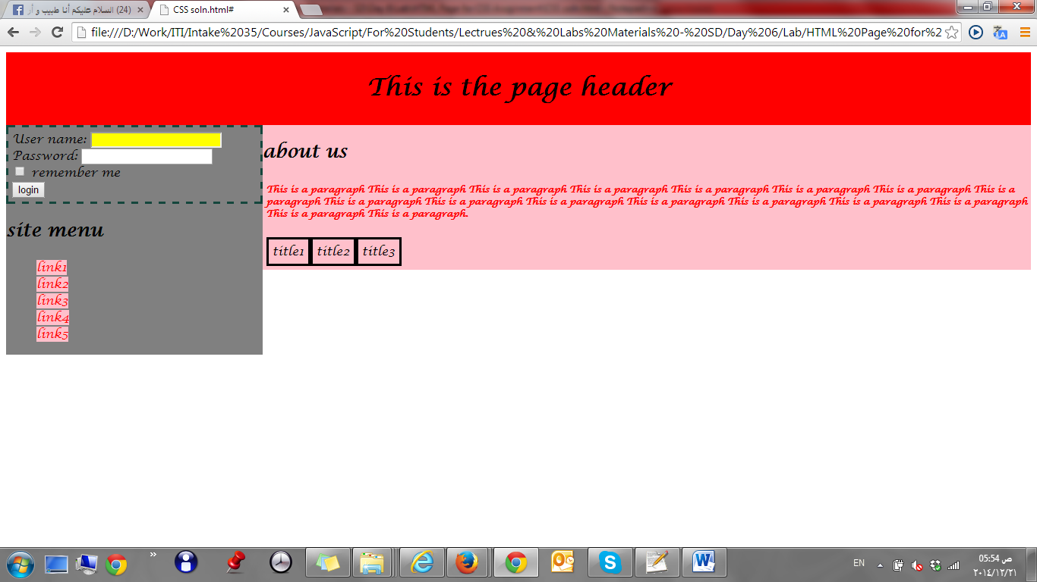

1. Make a Navbar like the following:

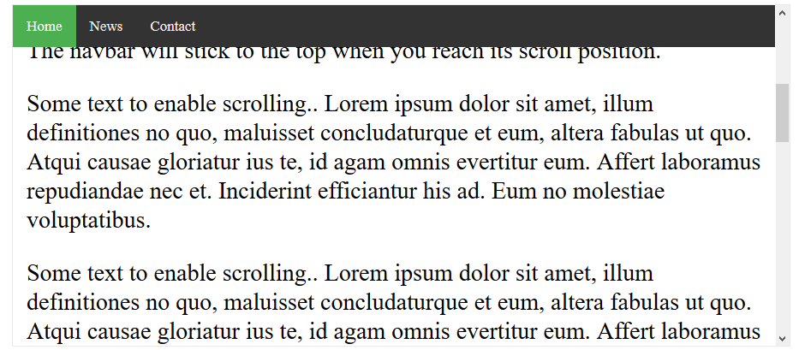

* 1. Make the navbar items as list (ul), and inside each list item (li), add a link for each menu item.
  2. Use list style type: none for the list items.
  3. Use display: inline-block for the list items. (Why?).
     1. What’s the difference between the following display values: inline, block, inline-block?

You can refer to the following links:

<https://www.w3schools.com/css/css_inline-block.asp>

<https://www.w3schools.com/cssref/pr_class_display.asp>

<https://stackoverflow.com/questions/9189810/css-display-inline-vs-inline-block>

<http://dustwell.com/div-span-inline-block.html>

<https://alligator.io/css/display-inline-vs-inline-block/>

<http://learnlayout.com/inline-block.html>

* 1. Handle that when mouse over an item its background color to be changed.

1. Made the previous navbar to be fixed position, and add any content below it (paragraph for example)
   1. You’ll need to push down the position all elements below the fixed elements, you may use padding property.
   2. Change the navbar to be position: sticky. (What’s the difference?).
2. On home page in Day.2 assignments, redo the page layout using CSS instead of table-based layout. (you can follow the following guidelines: (<https://www.w3schools.com/css/css_website_layout.asp>)
3. On the registration form in Day.2 assignments:
   1. Show * besides the required inputs (if you will use ::after pseudo element, you need to put each input inside a div or span, and apply ::after to the container div or span of the input, as the it will work with the elements that have content only)
   2. Make the inputs that are not valid has black border, and show span below it “Not valid” (use :invalid pseudo class).
   3. Make the inputs border white, and make the span below it not visible when the inputs become valid (use :valid pseudo class).
4. Make rounded link button as the following (Use <a> tag): 

**Bonus (Have fun with CSS J ):**

1. Calculate the specifity, for the 2 styles in assignment No. 6, in the part 1 assignments.
2. Search how to make an icon to your website that appears next to website title in the browser.
3. Redesign your home page to be similar (just use it as a template, it shouldn’t be exactly like it) to the following template (Don’t use table-layout)



* 1. Use background image in the header like the following: <https://www.w3schools.com/howto/tryhow_css_halfpage_demo.htm>
  2. Change the background image in the header, to be background video like this:

<https://www.w3schools.com/howto/howto_css_fullscreen_video.asp>

<https://medium.com/@aswin_s/fullscreen-video-backgrounds-e8376ef93c72>

* 1. Make the previous page as a single page, and handle transition when moving between different sections, and add a simple navbar on the top of page (When click each item it should redirects to the related section) like the following:

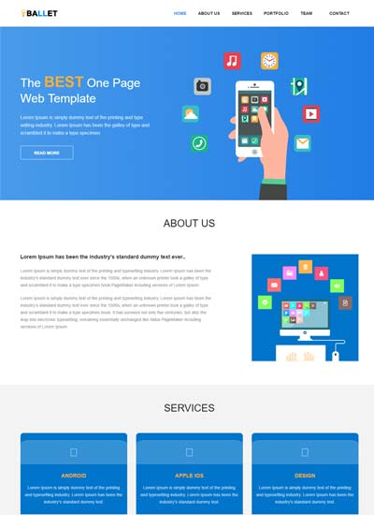

1. Style the registration page on Day.2 Assignments using CSS, to be like the following style: [http://demos.w3lessons.info/material-design-form/](http://demos.w3lessons.info/material-design-form/register.html) .html

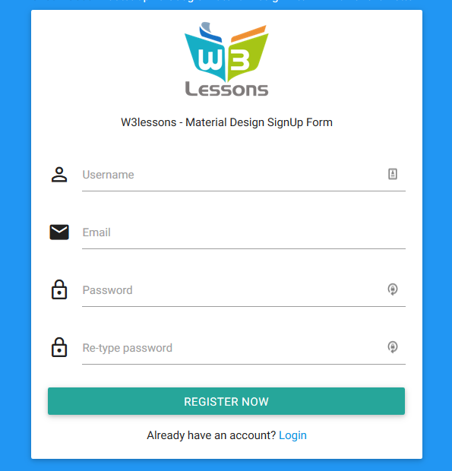

* 1. Make style the registration button to be like the prev. image full width and borderless. (Like the following button style).

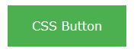

1. Follow the following demos to see how to center elements horizontally and vertically:  
   <https://www.w3schools.com/css/css_align.asp>   
   <https://css-tricks.com/centering-css-complete-guide>
2. Use z-index and position properties, to make a text above an image like the following:



* 1. Use opacity property to make the text transparent like the following:

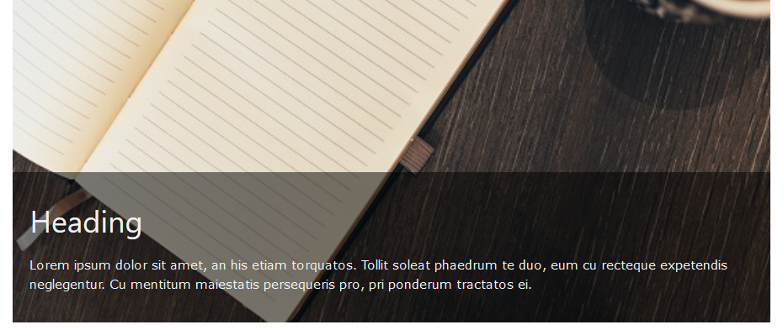

1. Create contact us form like the following:

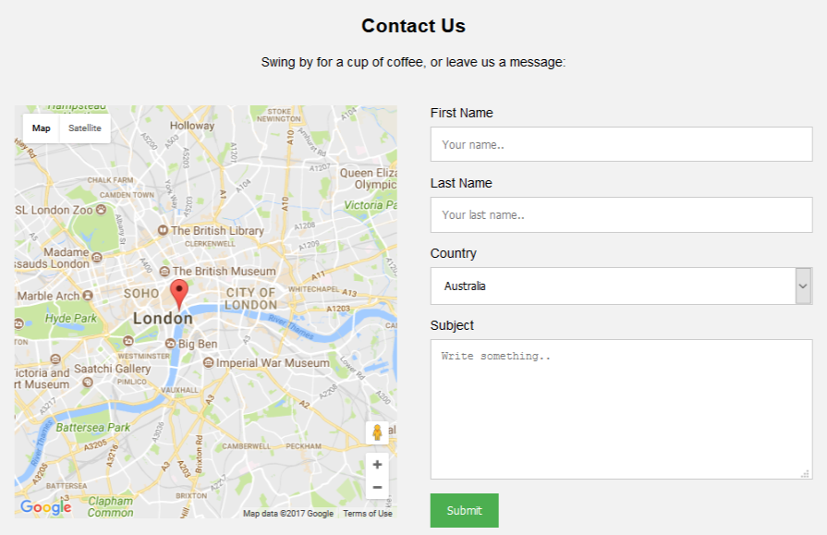

1. Design product card like this one:

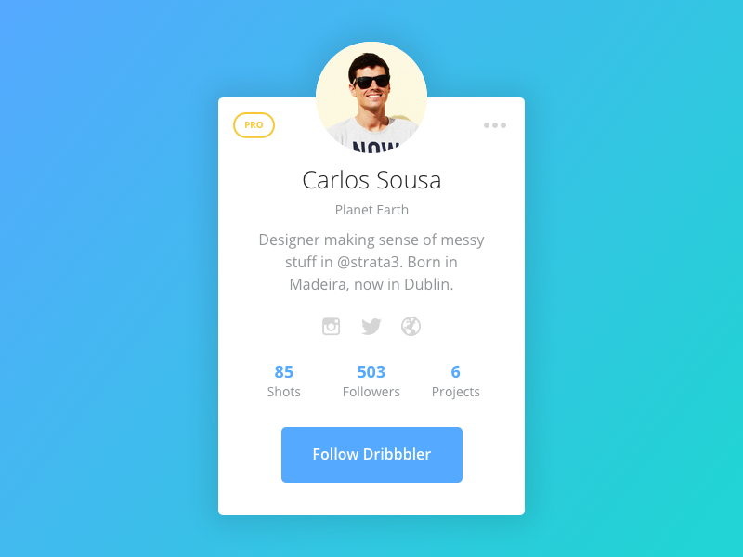

1. Create custom CSS checkbox and radio buttons like the following: <https://www.w3schools.com/howto/howto_css_custom_checkbox.asp>
2. Make full page background image with parallax scrolling effect (Scrolling background image) in a page, like the following website: <https://www.soundsnap.com> (Make a home page like this website with all CSS effects on it)  
   (You can follow the following demo to know about the parallax scrolling effect: <https://www.w3schools.com/howto/tryit.asp?filename=tryhow_css_parallax>).
3. Use CSS to make the following info bars (Without using bootstrap)

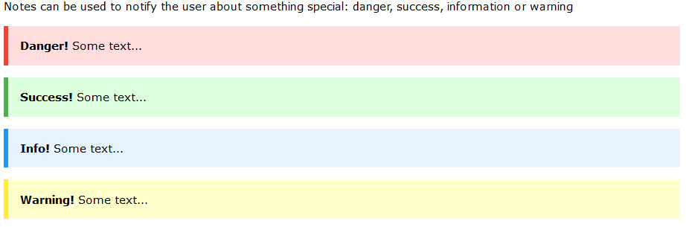

1. Use CSS to create HTML page that has dropdown menu like:

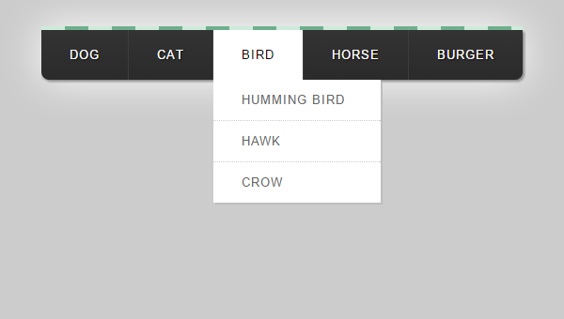

1. Use float property to make photo gallery like the following:

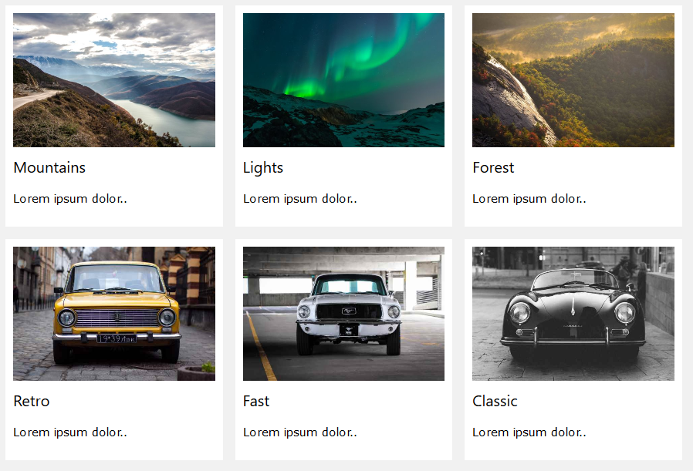

1. Create chat message like the following:

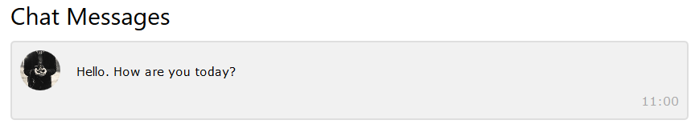

1. Review the following CSS Demos and code snippets and then redo them by yourself:
   * <http://cssdemos.tupence.co.uk/stepbystep/stepbystep-image-caption.htm>
   * <https://www.w3schools.com/howto/howto_css_full_page.asp>
   * <https://www.w3schools.com/howto/howto_css_fullscreen_video.asp>
   * <https://www.w3schools.com/css/css_tooltip.asp>
   * <https://www.w3schools.com/howto/howto_css_tooltip.asp>
   * <https://www.w3schools.com/css/css_navbar.asp>
   * <https://www.w3schools.com/css/css_dropdowns.asp>
   * <https://www.w3schools.com/css/css3_pagination.asp>
   * <https://www.w3schools.com/css/css_image_gallery.asp>
   * <https://www.w3schools.com/css/css3_buttons.asp>
   * <https://www.w3schools.com/howto/howto_css_timeline.asp>
   * <https://www.w3schools.com/howto/howto_css_overlay.asp>
   * <https://www.w3schools.com/howto/howto_js_sticky_header.asp>
   * <https://www.w3schools.com/howto/howto_css_fixed_sidebar.asp>
   * <https://www.w3schools.com/howto/howto_css_image_sticky.asp>
   * <https://www.w3schools.com/howto/howto_css_mega_menu.asp>
   * <https://www.w3schools.com/howto/howto_css_full_page.asp>
   * <https://www.w3schools.com/howto/howto_css_hero_image.asp>
   * <https://www.w3schools.com/howto/howto_css_parallax.asp>
   * <https://www.w3schools.com/howto/howto_css_profile_card.asp>
   * <https://www.w3schools.com/howto/howto_css_product_card.asp>
   * <https://www.w3schools.com/howto/howto_css_contact_chips.asp>

**<Script>document.write(“Thank YOU”) </Script>**